

Instructions for using the Simply Voting system
for voting in the of the University of Ljubljana,
Faculty of Computer and Information Science
Dean elections for the term of office
from 1 October 2026 to 30 September 2030

Table of contents
1. Description 3
2. Where and how to vote? 3
2.1. Step 1: Access to the system 3
2.2. Step 2: UL FRI staff login 3
2.3. Step 2: Student login 4
2.4. Step 3: Multi-factor authentication 4
2.5. Step 4: Ballot 5
2.6. Step 5: Voting 5
2.7. Step 6: Confirming your vote 6
2.8. Step 7: Ballot successfully submitted 7
2.9. Step 8: Voting receipt 8
3. Results 8
4. Technical support 8

Description
This document outlines the process for signing in and casting votes using Simply Voting, an online voting platform (hereinafter also: the system). The Simply Voting software allows secure electronic voting via sign-in with a UL single digital identity.
Access to the system is managed through the UL’s single sign-on, which includes multi-factor authentication (details in section 2.4). Voting results are stored with complete anonymity, ensuring that individual votes cannot be traced back to voters.

Where and how to vote?
The electronic voting portal is accessible at:
https://uni-lj.simplyvoting.com/

Step 1: Access to the system
When entering the portal, first click the green “Prijava” (Sign-In) button.

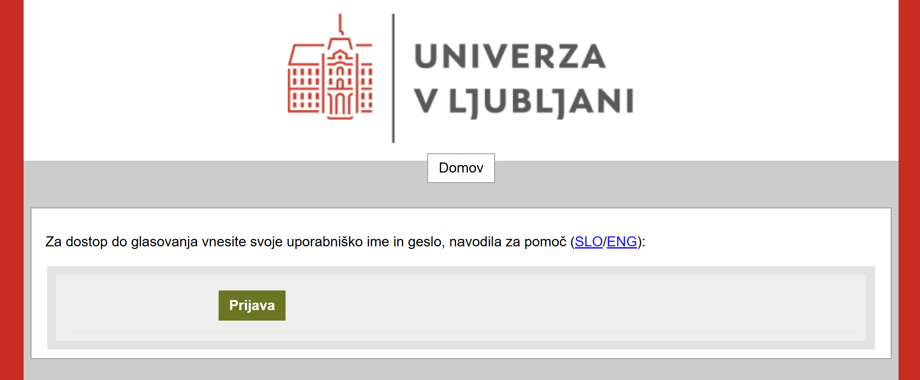

Step 2: UL FRI staff login
To access voting, employees must enter their University of Ljubljana digital identity (username and password used to sign into their work computer or services and systems, such as Fiori, OneDrive, Sharepoint, GC, STUDIS, ZOOM, Eduroam, Arnes etc.). Employee usernames take the form of an email address (e.g., username@fri1.uni-lj.si).

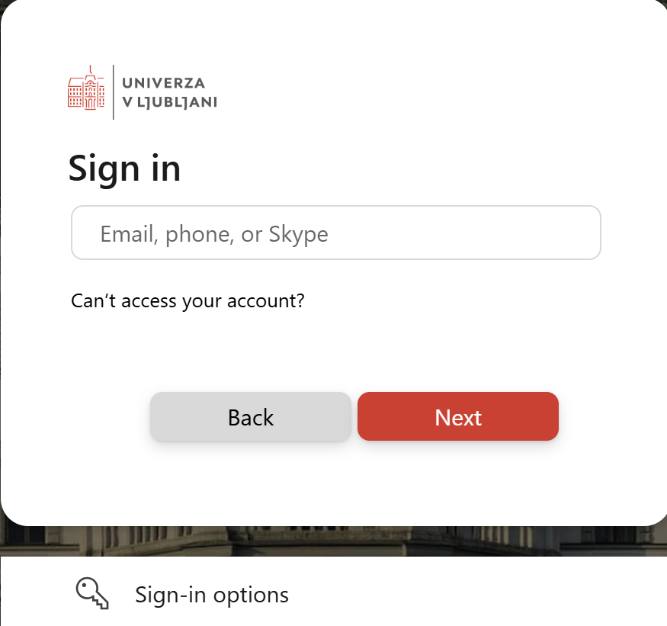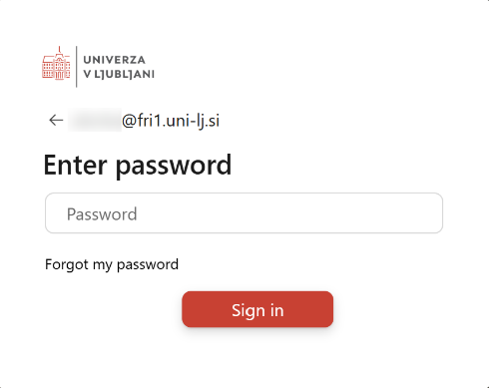

Step 2: Student login
To access voting, students must enter their University of Ljubljana digital identity in the following form: xx1234@student.uni-lj.si.
Students can check the operation of their digital identity on the ID portal site, on the following link: Check your username and password.

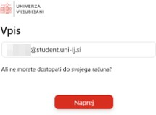

Step 3: Multi-factor authentication
The multi-factor authentication step applies to both employees and students.
When logging in, Simply Voting may prompt you for multi-factor authentication (a second-factor credential).

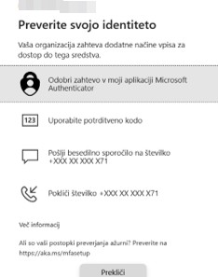

Step 4: Ballot
After successfully signing in, you will see a ballot “Volitve dekana FRI 2026” (FRI Dean Election 2026), as shown in the screenshot below.

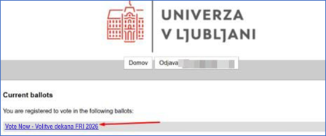

You will be able to access the voting by clicking the blue text of the polling station you have access to (link “Vote Now - Volitve dekana FRI 2026”).

Step 5: Voting
You have three options:
- Cast a valid vote by selecting a specific candidate, after which you will not be able to sign back into Simply Voting to change your vote.
- Abstain from voting by submitting an invalid ballot, after which you will not be able to sign back into Simply Voting to change your selection.
- Neither vote nor abstain, but simply sign out of Simply Voting, allowing you to sign back in and submit a valid or invalid ballot until 16:00 on election day.
Voting on behalf of another person or casting multiple votes in the same election is a criminal offense and may result in legal proceedings against the offender.
To vote for a candidate, tick the box next to the name of your chosen candidate.

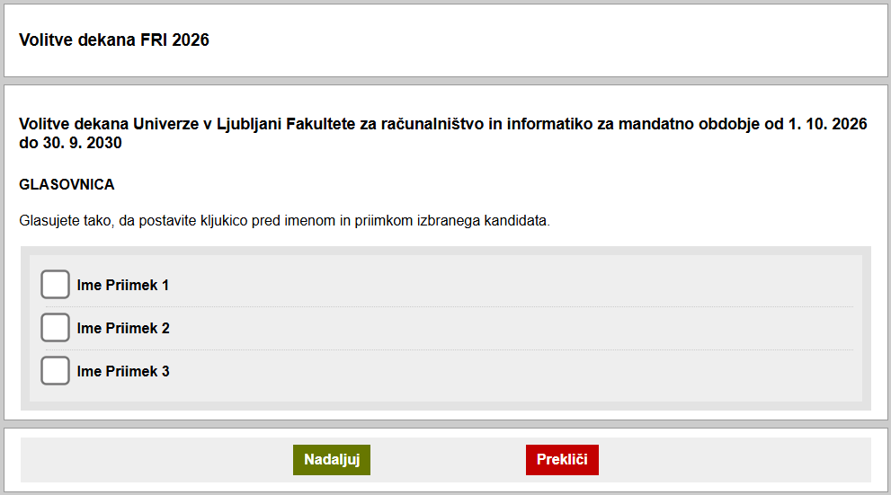

- Once you have ticked the box in front of the candidate's name, you can continue casting your vote by clicking the green “Nadaljuj” (Continue) button.
- If you wish to abstain from voting and cast an invalid ballot, tick nothing and continue by clicking the green “Nadaljuj” (Continue) button.
- If you do not want to vote, click the red “Prekliči” (Cancel) button.

Step 6: Confirming your vote
1. Voting for the selected candidate
If you have ticked a candidate, the system will take you to a page where you can check, change or confirm your selection.

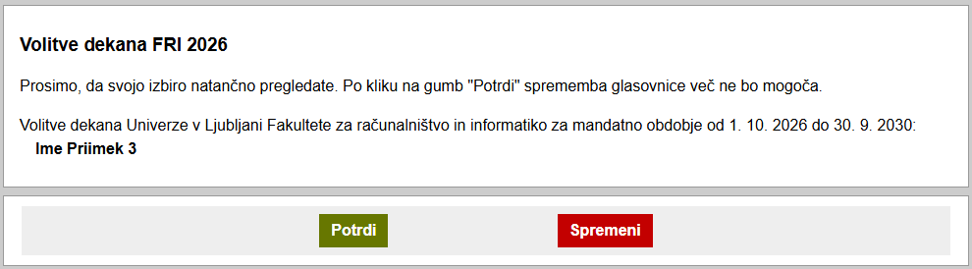

If you want to change your selection, click the red “Spremeni” (Change) button. The system will take you back to the ballot, where you can change your selection of candidate (Step 5). Click the green “Nadaljuj” (Continue) button to cast your vote. This will take you back to the page where you can check your selection (Step 6).
When you are satisfied with your selection, you can cast your vote by clicking the green “Potrdi” (Confirm) button. Once you click it, you can no longer change your ballot.
2. Abstain
If you want to abstain from voting and cast an invalid ballot, Abstain is displayed instead of the candidate’s name, as shown in the screenshot below:

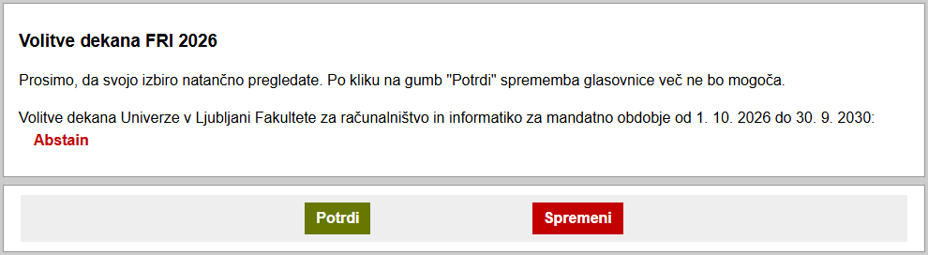

To change an invalid ballot, click the red “Spremeni” (Change) button. The system will take you back to the ballot, where you can change your selection of candidate (Step 5). Click the green “Nadaljuj” (Continue) button to cast your vote. This will take you back to the page where you can check your selection (Step 6).
If you decide to abstain and cast an invalid ballot (Abstain is displayed instead of the candidate’s name), click the green “Potrdi” (Confirm) button to continue casting an invalid ballot. Once you click it, you can no longer change your ballot.
3. Cancel voting
If you clicked the “Prekliči” (Cancel) button in Step 5, your vote was not cast. You may re-enter the Simply Voting system and submit your ballot (valid or invalid) until 16:00 on election day (Step 5 and Step 6).

Step 7: Ballot successfully submitted
Once you have successfully cast your vote, a green text as shown below will let you know that you have done so.

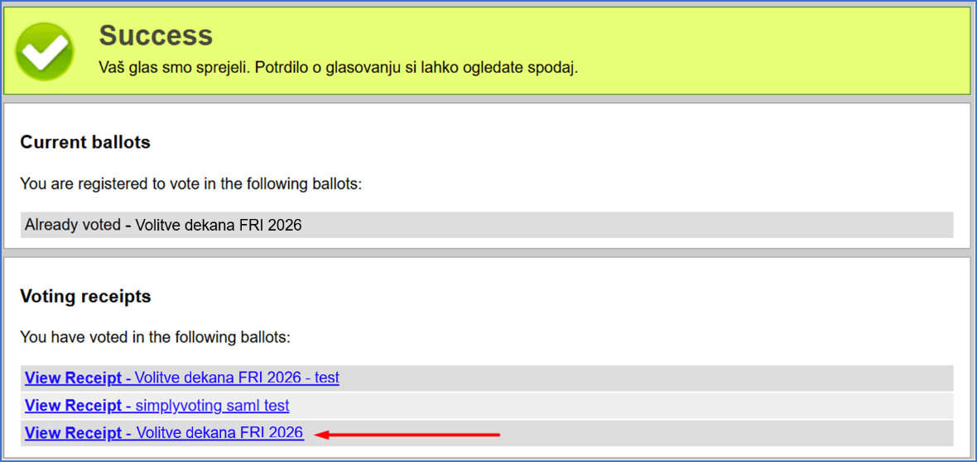

Step 8: Voting receipt
After casting your vote, you can obtain a digital confirmation of your vote by clicking on the blue-coloured text »View Receipt« for the ballot Volitve dekana FRI 2026 (Election of the FRI Dean 2026, see image at Step 7).
A window will appear with the submitted ballot receipt, which includes the receipt code, the time of the vote, and the IP address from which the voter accessed the Simply Voting system.

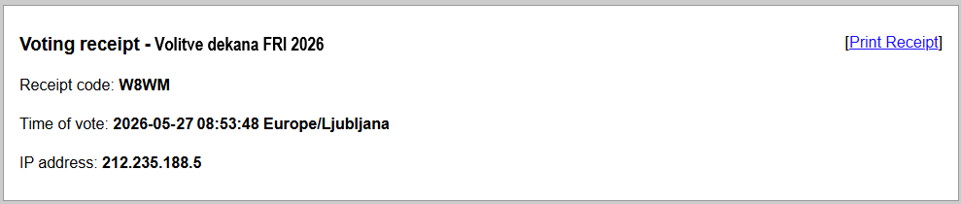

There is also a link to print this receipt (Print Receipt) on the left side.

Results
After the election, the Electoral Commission will determine the voting results and publicly announce the outcomes by publishing the minutes on the conduct of the election and the report on the election outcome on the Faculty’s website. The Chair of the Electoral Commission shall submit the minutes and the report to the Faculty Senate for notification and provide both documents as material for the first subsequent session of the Faculty Senate.

Technical support
In case of any issues, voters can contact support technician on duty Gašper Fele Žorž or his deputy Miha Schaffer. The contact phone number of the support technician on duty is +386 1 47 98 221.
During the election, the support technician on duty or his deputy are available at all times to address any technical issues. They must immediately inform the Electoral Commission of any problems and provide a report detailing how these issues impact the election process.
If, on the day of the election, it is discovered that an employee or student is not listed in the electoral register despite being eligible, they must be able to contact the support technician on duty, who will verify the issue and take the necessary steps to update the electoral register and grant access to the electronic election system immediately (within the duration of the election).
Questions regarding the dean election process and any potential issues can also be sent to the Electoral Commission's email address volitve.dekana@fri.uni-lj.si.

